Thai Thanh Dat

# 1) OVERVIEW

Full name: Thai Thanh Dat

Date of Bird: 26/01/1999

Sex: Male

Nationality: Vietnamese

Mobile: 0921083980

Email: [thaithanhdat125@gmail.com](mailto:thaithanhdat125@gmail.com)

**2) CAREER OBJECTIVES**

I want to find a suitable job that i can learn new things, exchange experiences with other people so I can improve my skills and apply my knowledge in the workplace.

I also want to create new relationships with everyone. We can help each other at work when having problems.

Always learn, do my best to finish tasks from the manager .

**3) TECHNICAL SKILLS**

|  |  |
| --- | --- |
| OS | Windows XP, Windows 7 |
| Programming  Languages | JavaScript |
| Databases | MS SQL Server |
| Packages | MS Visual Studio, MS Office, Xamppe |

**4) LANGUAGES SKILLS**

Vietnamese: Native language

English: Able to read/write technical documents

**5) EDUCATION, QUALIFICATIONS**

September 2017 –

January 2022

University Nha Trang (IT)

**6) OTHER SKILLS & SPECIAL ARCHIVEMENTS**

* Good soft skills, team works.
* Fast learning, self motivated.
* Easily adapt to new environment.
* Planning, estimating the time for work.

1. **LEARNING OUTCONES**

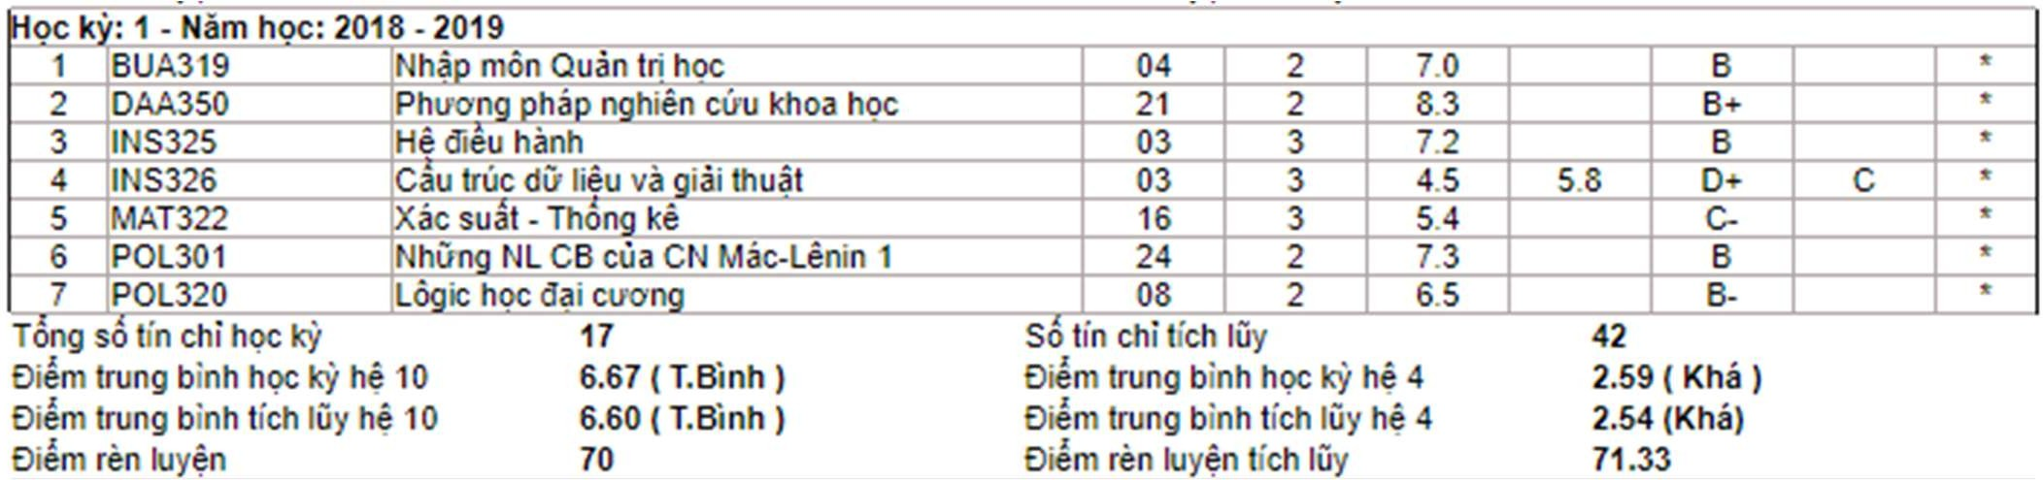

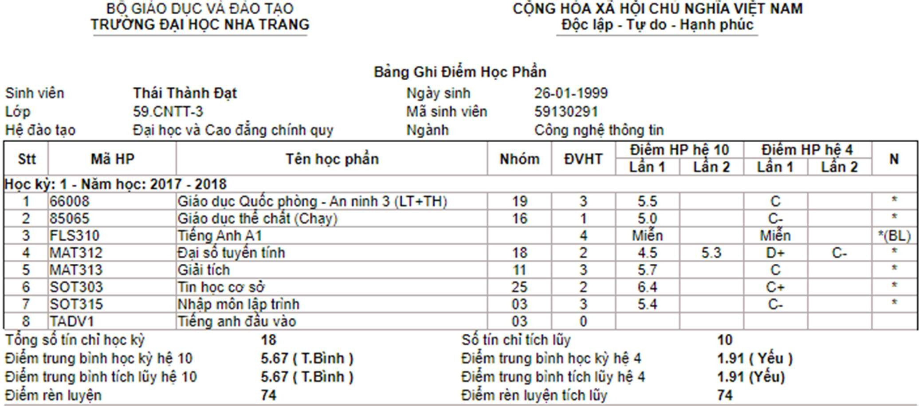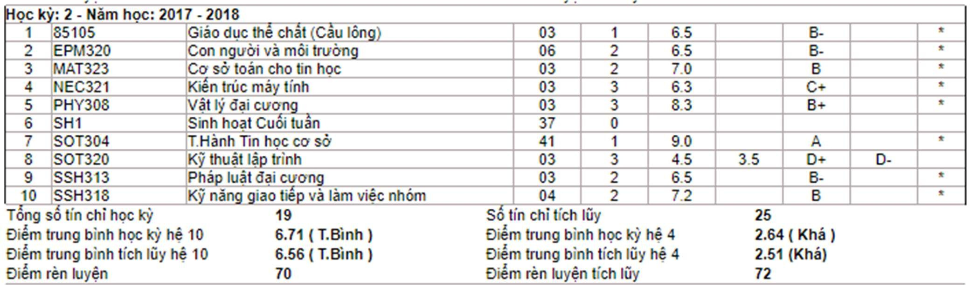

oc k’ : 2 - Ham h : 2018 - 2019

* 1. 66007 Giâo duc Qu c én - An ninh 2 30 tie!

|  |  |  |  |  |  |
| --- | --- | --- | --- | --- | --- |
| 2 85097 | Giâo due the chat 8é dâ | 07 | 1 | 8.0 | g+ |
| 3 INS330 | Co sé' do Ii5u | 03 | 3 | 7.4 | B |
| 4 NEC329 | Man ma tfnh | 03 | 3 | 7.6 | B |
| 5 POL3J8 | Nh* NL CB ciia CN Mac-Lénin 2 | 12 | 3 | 6.3 | C• |
| 6 SOT332 | oân féirac | 03 | 3 | 9.3 | A |
| 7 SOT336 | K“ thuât do hoa | 03 | 3 | 6.B |  |
| 8 SOT347 | iel ke Web | 03 | 3 | 4.3 |  |
| 9 SOT375 ie Anh chu en n ânh CN thén tin 03 3 6.9 & ong so tin chi hoc 24 So tin chi tfch luy | | | | | |

01 2 7.5 B



T

Diem trung binh hoc hd 10 6.94 ( T.Binh ) Oicm trung binh tich I6y he 10 6.84 ( T.Binh )



Oum trung binh hoc he 4 Diem trung b‹nh lich liiy hd 4 Diem ran kiydn tfch lñy



2.67 ( Khé )

2.67 (Khé)

**71.75**

Hoc : 1 - Ném hoc: 2019 - 2020 

|  |  |  |  |  |  |  |  |
| --- | --- | --- | --- | --- | --- | --- | --- |
| 1 '66006 Giâo duc Quoc én - An ninh 1 45 tic! 10 | | | | 3 | 7.2 | B | ° |
| 2 INS335 kd ma tinh 03 | | | | 3 | 6.5 |  |  |
| 3 ›INS336 | He tho thén lv dia l “ GiS | | 03 | 3 | 6.S | & | * |
| 4 INS339 | Hd uân tri co sé d0' lidu | | 03 | 3 | S.8 | C | • |
| 5 INS359 | o an Phân tfch thia! ke hd than tho | tin | 03 | 1 | S.7 | C | |
| 6 INS360 | Phân tfch thiel ke he tho thén tin |  | 03 | 3 | 6.1 | C• | |
| 7 NEC337 **uan** mann 03 | | | | 3 | 6.9 | B- | ” |
| 8 POL333 | o luân Ho Chi Minh | 14 | | 2 | 6.7 | & | ’ |
| 9 SOT331 | Lâ trinh fitré doi tuo | OJ | | 3 | 6.3 |  |  |
| JO SOT376 â Co s6’ Cén n hd tho tin 03 | | | | 2 | 8.5 A- ” | | |

Tong so tfn chi hoc Iq/

Diem trung binh hoc hfi t0 Oiem trung binh tich luy he 10 Diem ren kiyén

k‘ : 2 - Ném hoc: 2019 - 2020



6.S4 ( T.Binh )

6.75 ( T.Binh )



So tin clii tfch liiy

Diem trung binfi hoc he 4 Oiem #ung binh tich luy he 4 Oem rén kiyen tfch lñy



2.56 ( Khé )

2.64 (Khé) 72.4

1. FLS3J2 ie Anh A2.1
   1. INS366 Cén he XML vâñ du

|  |  |  |  |  |  |
| --- | --- | --- | --- | --- | --- |
| 3 PHY307 | Hânh Vât I” dais | IN | 1 | 7.2 | B |
| 4 POL340 | uén loi CM cua Oâ CS Viet Nam | IJ | 3 | 7.5 |  |
| 5 SOT320 | K” thuâl lâ I inh | 03 | 3 | 6.8 | B- |
| 6 SOT349 | C6n h5 an rn«m | 03 | 3 | 6 7 | B- |
| 7 SOT353 | Mau thiel ke | 03 | 3 | 7.5 |  |
| 8 SOT355 |  | 03 | 3 | 8.1 | B+ |
| 9 SOT3S6 | Lâ trinh | 03 | 3 | 6.5 |  |

22 4 7 5 B

03 3 8.3 B+









10 SOT358 Tong so lin chi hoc

a an ât tñen ‘ dun Web

27

03 1 8.5

So lin chi tfch Iñy

A-

106

Diem trung binh hoc kt he 10 Diem trung bifih tfch luy hd 10



oc ' : 1 - Ném hoc: 2020 - 2021

7.39 ( Khé )

6.89 ( T.Binh ) 82

Diem bung binh hoc he 4 Oiem tning binh lfch luy hd 4 Oiem ren luyen t‹ch Iñy

2.99 ( Khé )



74

1. FLS313 ie Anh A2.2
2. SOT344 ri lud nhân tao
3. SOT348 â N ânh 6 tuan
4. SOT352 Quân pdaonan han mem

17 4 7.5 B

03 3 5.5 C

03 3 8.0 B+

03 3 7.9 B

1. SOT3S7 Kism Ihd han mem
2. SOT366 Phât tñen an mem mâ n uon mé Tong so tin chi hoc Iq/ 19

Diem trung binh hoc hc 10 6.94 ( T.Binh ) Diem trung binh tich Idy hd 10 6.90 ( T.Binh ) **Diem rim kyen 84**

oc k’ : 2 - Ném hoc: 2020 - 2021

1. FLS314 ›e Anh B1.1
2. INS358 u' I “ dll liéu lén
3. INS362 Khai hâ dll litu
4. NEC354 Chu dn de tot n hi“ Cé he than tin
5. SOT347 iet ke Web
6. SSH32S K” nâ iâi gill/et van de vâ ra putt dinh Tong so tin clii hoc 19

Oiem trung binh hoc hd 10 7.95 ( Khâ ) Oiem trung binh tich luy hd 10 7.04 ( Khé ) Oiem ren kiyen 0

03 3 6.9

03 3 6.4

So tin chi tfch Iñy

Oism trung binh hoc hd 4 Diem trung binh tich luy hd 4 Diem in luydn lich Iñy

18 4 8.4

01 2 S.0

01 3 7.3

03 5 6.5

01 3 9.3

05 2 7.6

So lin chi *lich* luy

Diem trung binh h0c hd 4 Diem trung binh tfch ldy he 4 Diem ré'n luyen tich Iñy



C+

121

2.66 ( Khé )



B+



B



A B



3.27 ( Gioi )

2.78 (Khâ) 74.86

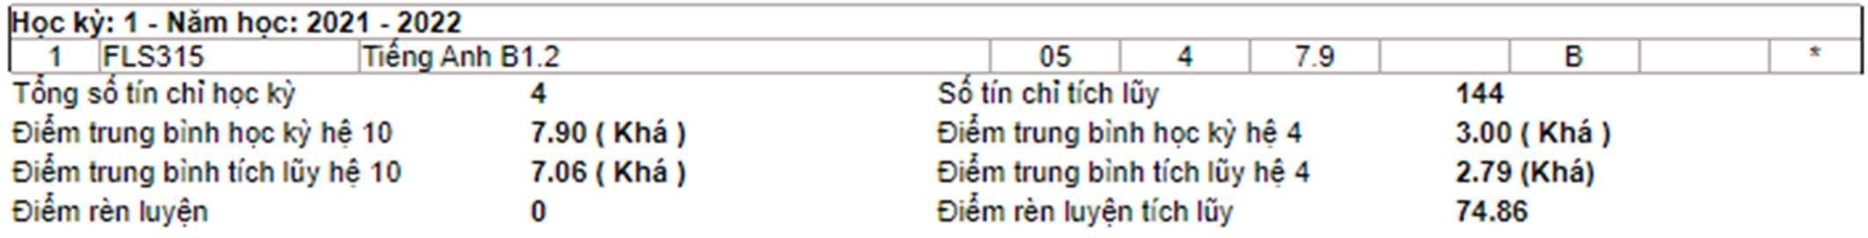

End